DAV BR PUBLIC SCHOOL,BINA
SESSION 2023-24
Steps to download report cards from osm on mobile:

- Visit https://davbr.org/osm
- Enter Username as your 4 digit Admission No. e.g. 0415
- Enter password as your Date of birth in ddmmyyyy format e.g. 21052010
- Go to Menu on left hand side and select Examinations option.
- Click at View button.
- Set the option Request Desktop Site – On from settings in Mozilla Firefox on mobile.
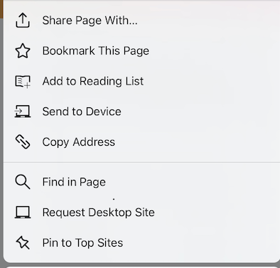
- Download or take a print out of your report card for your future reference.
- Previous report cards will be overwritten by the new one.
- For any difficulty contact your class teacher.
- Use latest version of Mozilla Firefox downloaded from play store.

